PROJECT ON FANTASY CRICKET GAME

It is an online game where you create a virtual team of real cricket players and score points depending on how your chosen players perform in real life matches. To win a tournament, you must try and get the maximum points and the No. 1 rank amongst other participants. Here's how a Fantasy Cricket game may look like

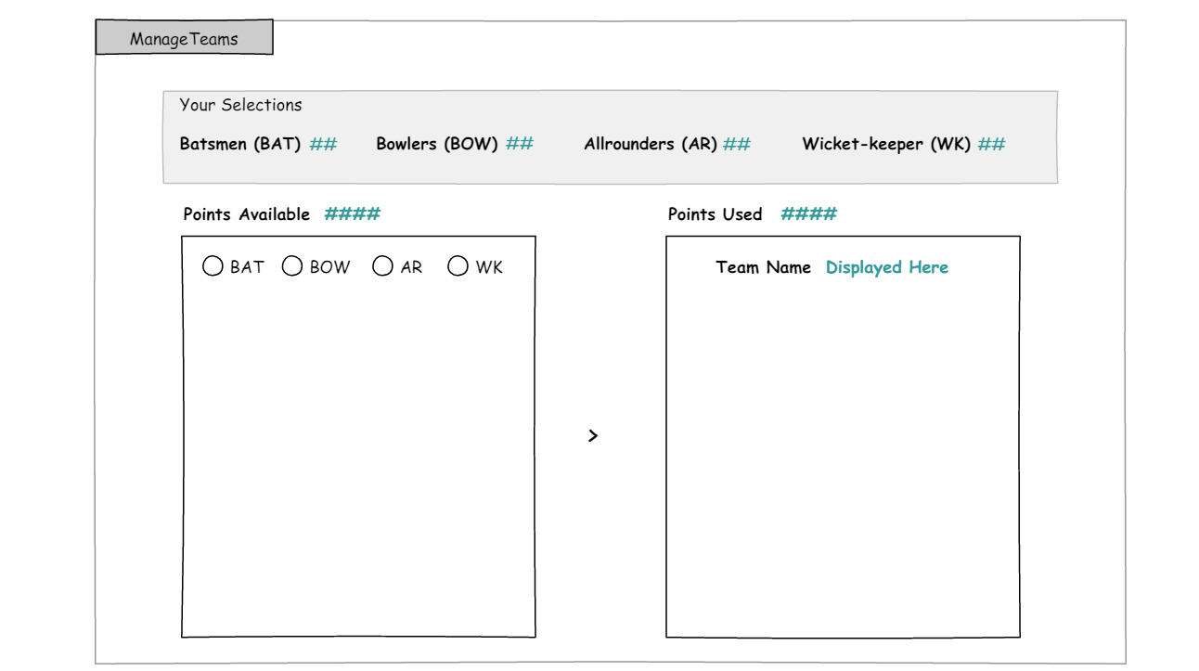

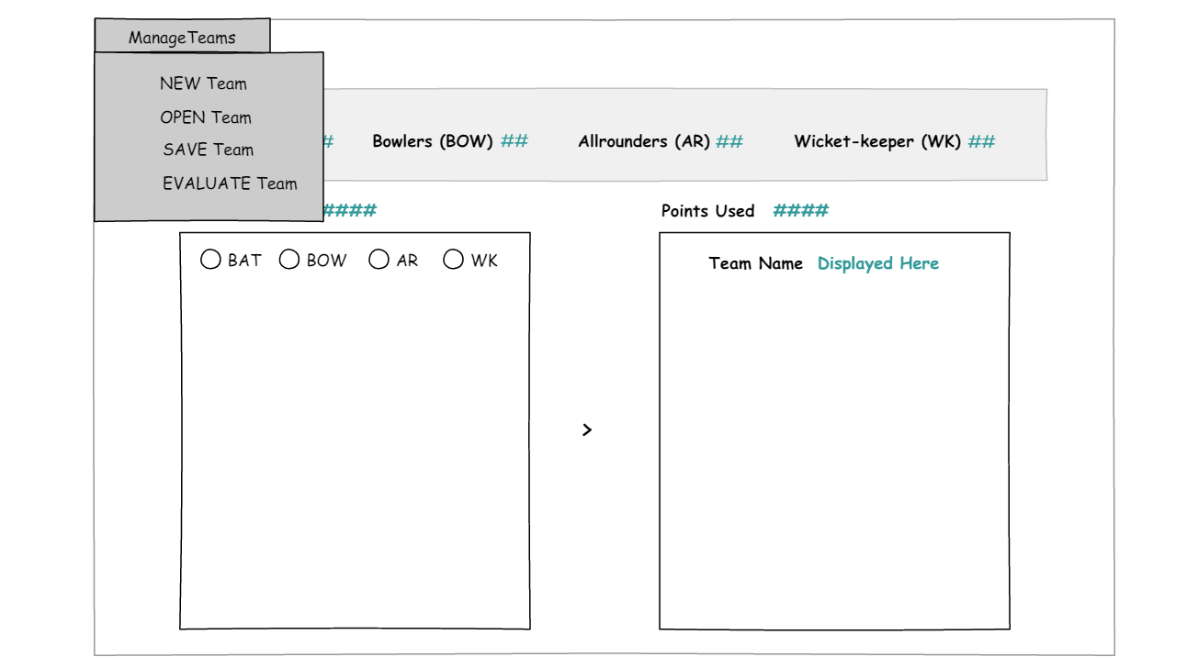

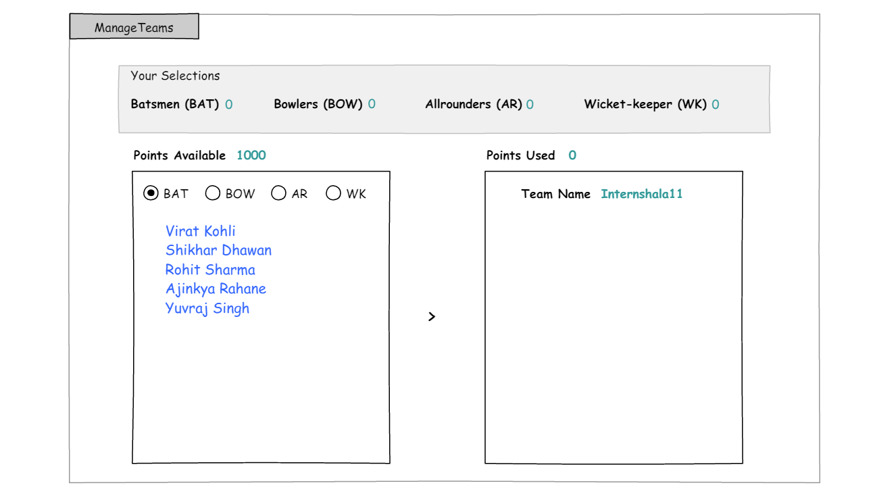

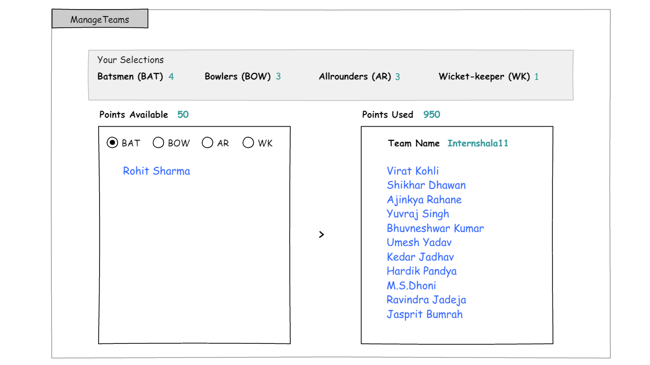

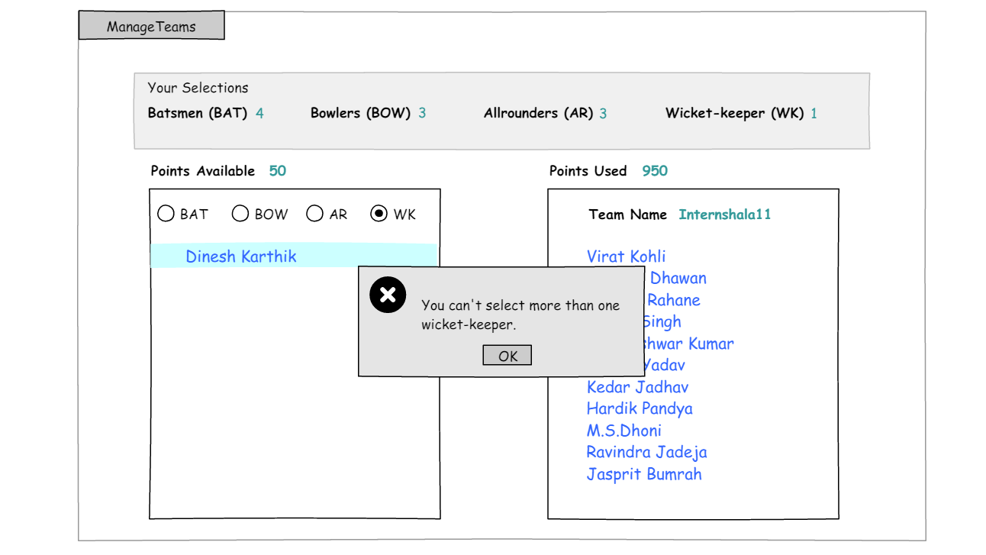

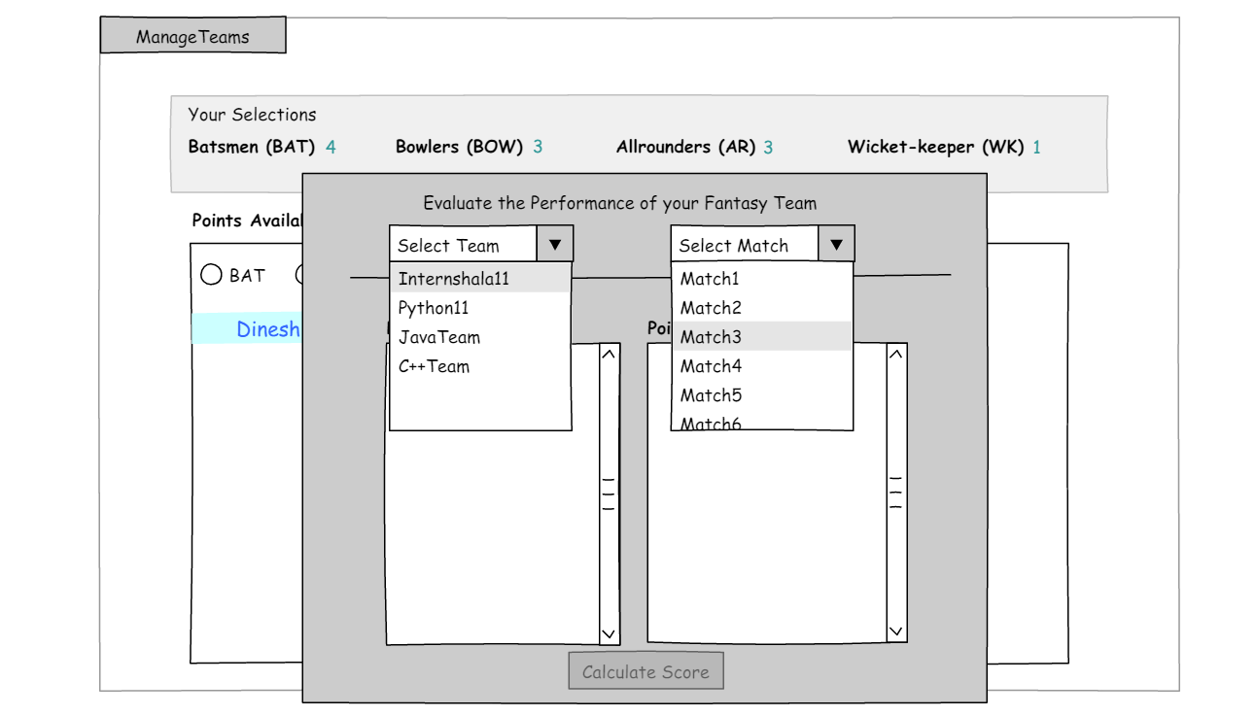

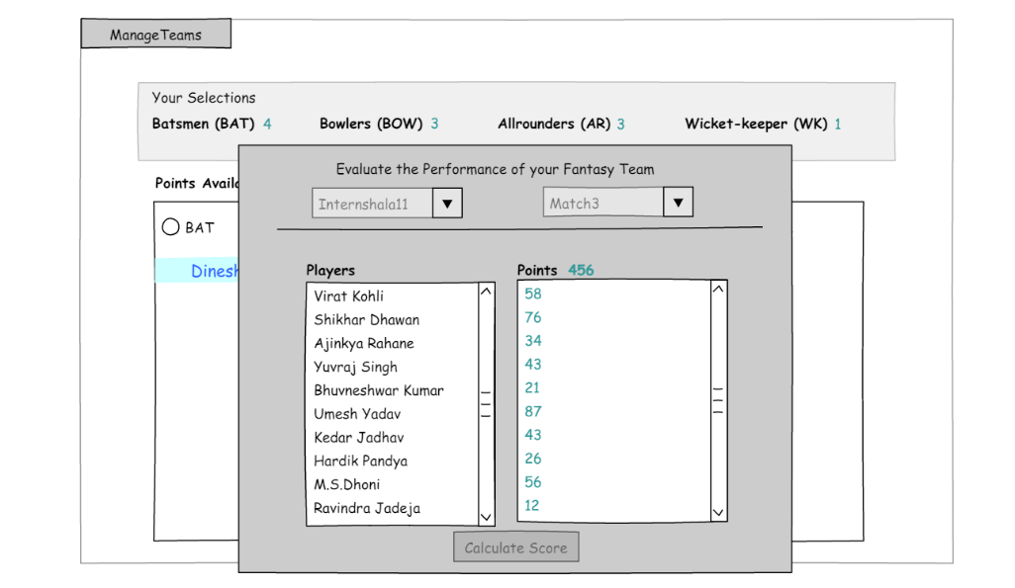

Technology used:

1. Python (language)

. Basic knowledge (loops ,functions , connections etc..)

. PYQT5 (install)

. QT designer (To make GUI- use of icons, boxes etc…)

1. SQL or Excel Sheet for Database ( for connecting data )

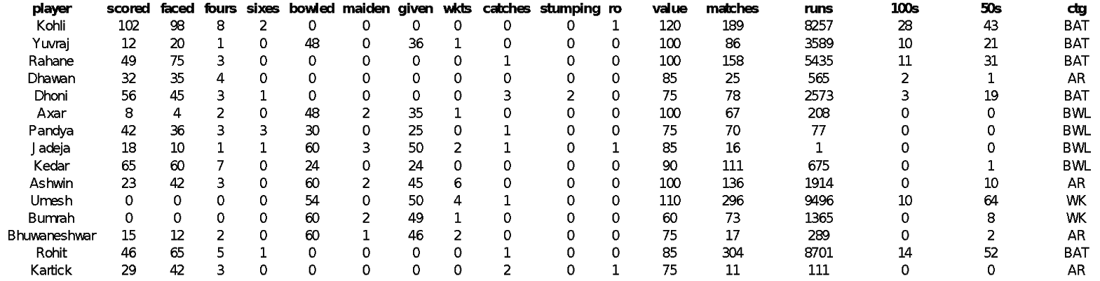Data Base design:

1. First, create the database of players.
2. Plan the required tables and add data to your database.
3. Next, create the GUI. Generate the required Python code for the UI.
4. Finally, populate the Python code generated in step ii with more attributes and method definitions (action listeners).

The following things required :-

|  |  |  |
| --- | --- | --- |
| Elements | Categories | Criteria |
| Application |  |  |

|  |  |  |
| --- | --- | --- |
|  | Flow | Populate left list widget from database as per category radio button clicked |
|  |  | Add players from players list to selected players list |
|  |  | Remove players from selected players list to players list |
|  |  | Show error if selection criterion is violated |
|  |  | Calculate team score |
|  | UI | Widgets should be placed symmetrically |
| Code |  |  |
|  | Naming Convention | Meaningful variable names |
|  |  | Meaningful function names |
|  | Modularity | A single function should be used for a single task/No code repetition (make generalized functions) |
|  | Error Handling | Implement error handling wherever required |
| Database Design |  |  |
|  | Tables | Number of tables |
|  |  | Column names |
|  |  | Data types |
|  |  | Data |

ssss